Questions:
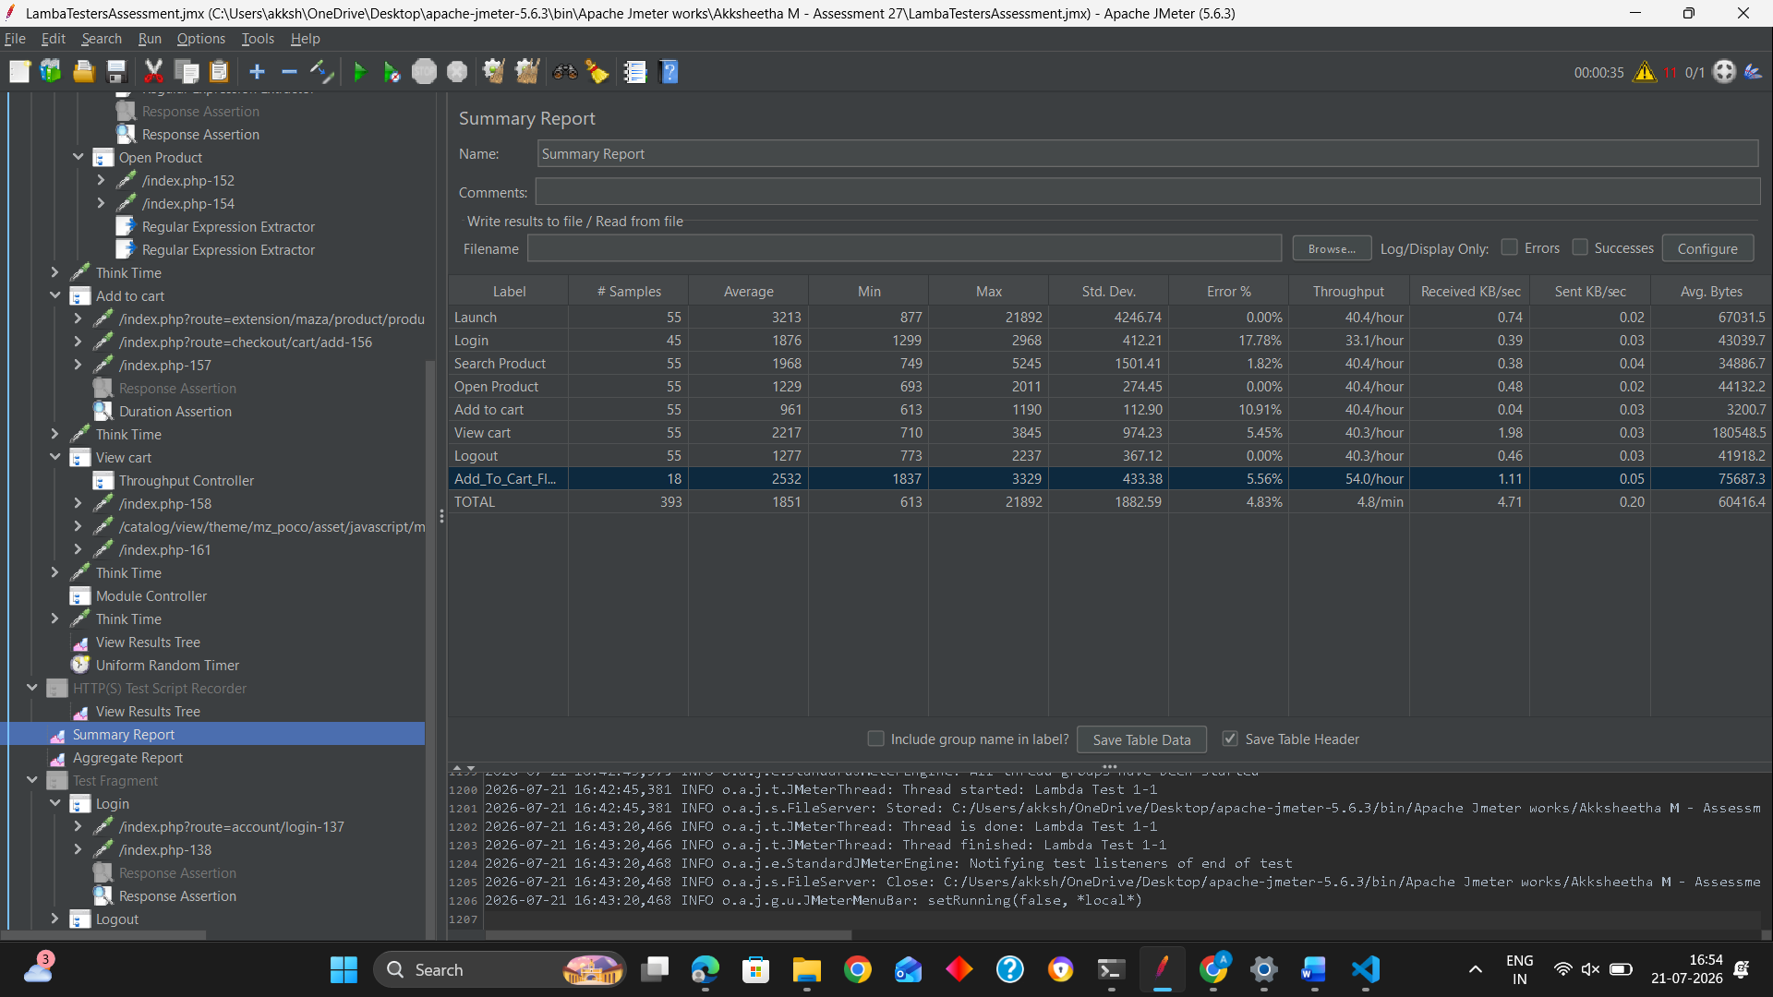
1)Highest response time => 21892
2)Lowest Response Time => 613
3)Maximum Throughput:Add to cart flow => 54.0/hr
4)Error Percentage => 4.83
5) Average response time => 1851
6) Average response time => 1370
7)90th percentile => 2761
8)95th => 3576

